|  |  |
| --- | --- |
| **Name** | Adrian Leo Pradana |
| **NPM** | 2106718344 |

1. Algorithm is a set of instruction to achieve a specific goals, it tells the computer how to transform a set of facts about the world into useful information. There two tools to create an algorithm that is flowchart and pseudocode, the difference between two of them is that pseudocode is an informal high-level description of an algorithm while flowchart is a pictorial representation of an algorithm.

**References:**

● <https://www.investopedia.com/terms/a/algorithm.asp>

● <https://www.techwalla.com/articles/differences-between-psuedocode-and-flowcharts>

1. Flowchart shape and its functionality :

Called terminator, indicates the beginning or end of a program flow in a diagram

Called decision point, between two or more paths in your flowchart

Called process, have a purpose as processing function

Called data, represent any type of data in flowchart

called on page reference, used to connecting process in the same worksheet

**References:**

● <https://www.edrawsoft.com/flowchart-symbols.html>

1. First it will read the data with variable a and b, then in goes to if condition if a > b then it will print “a is larger” else if a < b then it will print “b is larger” else it will print “they’re the same” then the program will finish by the end.

**References:**

● <https://www.computerhope.com/jargon/i/ifstatme.htm>

1. The variable that are provided is a , b and counter assign with 0 and also variable next. Then it will enter the iteration that is while counter < 10 it will print the value of a and assign the value of next with a + b, then the value of b will be assign to a, and the value of b assign with next, and do an increment with counter variable, the value of a will remain 0 because there is no operation that change the value of a, the value of a will be print 10 times.

**References:**

● <https://searchsoftwarequality.techtarget.com/definition/iterative>

1. Flowchart

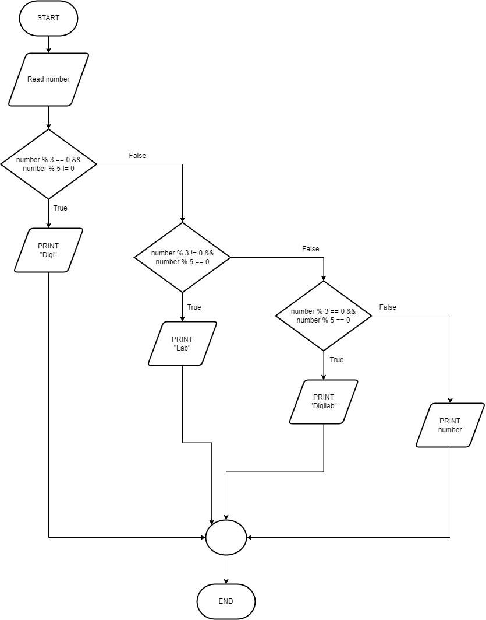

Pseudocode

|  |  |
| --- | --- |
| **Determine is the number multiply of 3 or 5** | |
| 1: | **int $number$** |
| 2: | **if** number % 3 == 0 &&  number % 5 != 0 |
| 3: | **Print $"Digi"$** |
| 4: | **Else if** number % 3 != 0 &&  number % 5 == 0 |
| 5: | **Print** "Lab" |
| 6: | **Else if** number % 3 == 0 &&  number % 5 == 0 |
| 7: | **Print** "Digilab" |
| 8: | **Else** |
| 9: | **Print** number |
|  | **Endif** |

**References:**

● <https://www.geeksforgeeks.org/multiples-of-3-or-7/>